AI-ASSISTED CODING
ASSIGNMENT-4.3
Advanced Prompt Engineering – Zero-shot, One-shot, and Few-shot Techniques
---------------------------------------
NAME: Adepu Goutham Sri Bhargav
HALL-TICKET: 2403A510C4
BATCH NO: 05

Task 1:
● Zero-shot: Prompt AI to write a function that checks whether a given year is a leap
year.
Prompt:
Zero-shot: write a function that checks whether a given year is a leap year. what does the prompt mean
CODE SCREENSHOT:
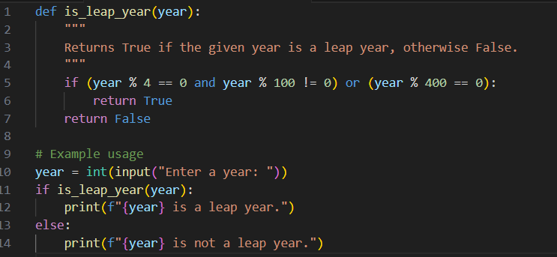

OUTPUT:
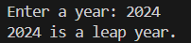

EXPLANATION:
The prompt “Zero-shot: write a function that checks whether a given year is a leap year” means:
- Zero-shot → You are asking the AI to solve a problem without showing it any example or prior context.
- The AI uses its existing knowledge to create a solution.
How this relates to the prompt:
- The prompt asked for a function to check leap years.
- The AI understood the rules of leap years and wrote this function without seeing any example—that’s zero-shot.
- The function:
  - Takes a year as input.
  - Checks if it’s divisible by 4 but not by 100, or divisible by 400.
  - Returns True if leap year, otherwise False.

--------------------------------------------------------------------------------------------------------------
Task 2:
● One-shot: Give one input-output example to guide AI in writing a function that converts centimeters to inches.
Prompt:
write a function that converts centimeters to inches. For example : 1 inch = 2.54 centimeters.
CODE SCREENSHOT:
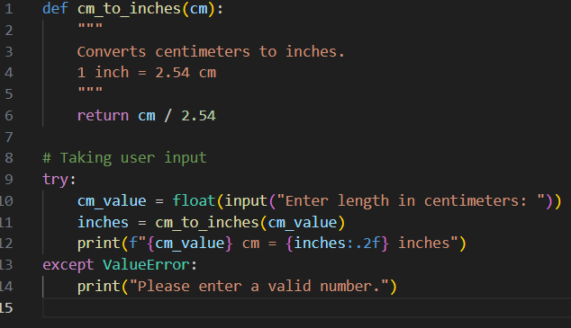

Output:
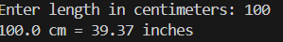
Explanation:
Here’s what “one-shot” means using your example prompt:
- One-shot means the AI is asked to solve a task after seeing exactly one example of how it should be done.
- Unlike zero-shot (no examples) or few-shot (multiple examples), here you give just one sample to guide the AI.
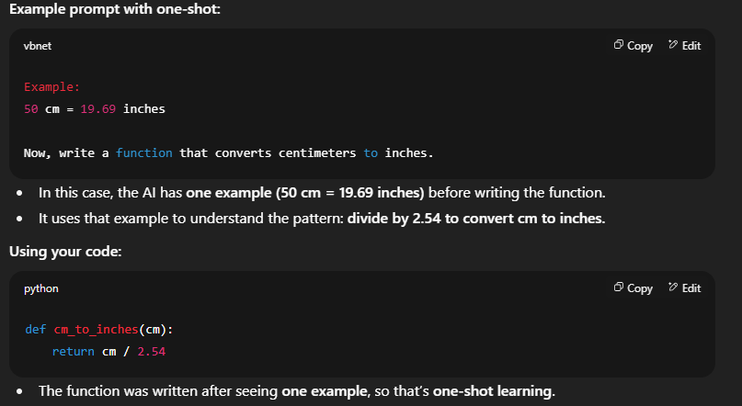

----------------------------------------------------------------------------------------------------------
Task 3:
● Few-shot: Provide 2–3 examples to generate a function that formats full names as
“Last, First”.
PROMPT:
Examples:
Input: "John Smith" → Output: "Smith, John"
Input: "Alice Johnson" → Output: "Johnson, Alice"
Input: "Michael Jordan" → Output: "Jordan, Michael"
Now, write a function that takes a full name and returns it in the format "Last, First".

CODE:
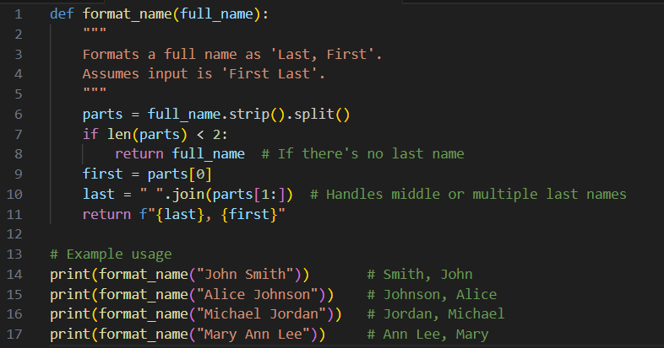

OUTPUT:
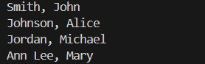
EXPLANATION:
- strip() removes any extra spaces at the start or end.
- split() breaks the string into a list of words using spaces.
Example: "John Smith" → ["John", "Smith"]
- Check if there are at least two words:
If not, it returns the original input.
- first = parts[0] stores the first word as the first name.
- last = " ".join(parts[1:]) joins all remaining words into one string (to support middle or double last names).
- return f"{last}, {first}" returns the formatted string.
Output Examples
- Input: "John Smith" → Output: "Smith, John"
- Input: "Mary Ann Lee" → Output: "Ann Lee, Mary"

------------------------------------------------------------------------------------------------------------------------------------
TASK 4:
● Compare zero-shot and few-shot prompts for writing a function that counts the
number of vowels in a string.
PROMPT:
i ) Write a Python function that counts the number of vowels (a, e, i, o, u) in a given string.
Ii ) Examples:
Input: "Hello" → Output: 2
Input: "Programming" → Output: 3
Input: "OpenAI" → Output: 3
Now write a Python function that counts the number of vowels (a, e, i, o, u) in any given string.
CODES:
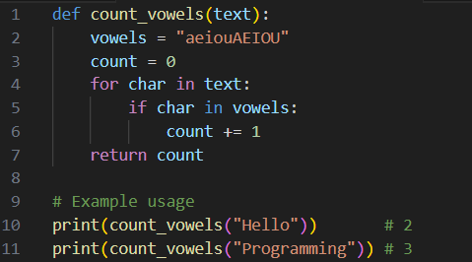
OUTPUT:
Code ii:
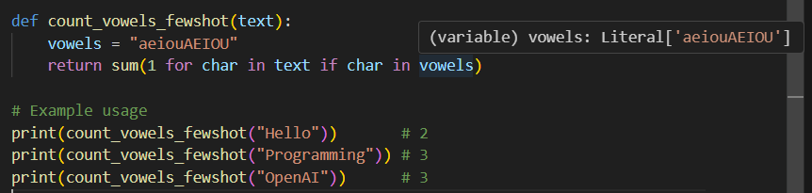
Output ii:
EXPLANATION:
1. Zero-shot scenario
- Prompt: “Write a Python function that counts the number of vowels (a, e, i, o, u) in a given string.”
- What happens:
The AI is asked to solve the problem without any examples. It relies only on its general knowledge of Python and string handling.

  - Loops through each character.
  - Checks if it’s a vowel (case-insensitive).
  - Counts vowels and returns the result.
- Example output: "Programming" → 3
2. Few-shot scenario
- Prompt: “Examples: ‘Hello’ → 2, ‘Programming’ → 3, ‘OpenAI’ → 3. Now write a Python function that counts the number of vowels in any string.”
- What happens:
The AI is given 2–3 examples before solving the problem. These examples show exactly what kind of input and output are expected. The AI uses these patterns to generate the function.
  - Uses a compact approach (generator expression) because the examples suggest a simple counting task.
  - Still counts vowels case-insensitively.
- Example output: "OpenAI" → 3

Key Difference
- Zero-shot: No examples, AI infers everything from the question. May write more step-by-step or longer code.
- Few-shot: Few examples help clarify expectations, often resulting in shorter or more precise code.

--------------------------------------------------------------------------------------------------------------

TASK 5:
● Use few-shot prompting to generate a function that reads a .txt file and returns the
number of lines.
Prompt:
Examples:
Input file content:
Line one
Line two
Line three
Output: 3
Now write a Python function that reads a .txt file and returns the number of lines.
CODE :
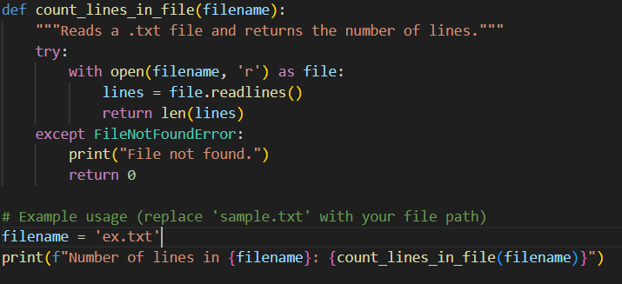
Txt file:
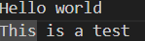
Output:

Explanation:
Few-shot prompt meaning here
- We give 2–3 examples of what the input (file content) looks like and what output we expect (number of lines).
- Example shown in the prompt:
- Input file content:
- Hello world
- This is a test
- Output: 2
- These examples teach the model the pattern before asking it to generate the function. This is called few-shot learning because the model learns from a few examples.
How it works:
- with open(filename, 'r') as file: – Safely opens the .txt file for reading.
- file.readlines() – Reads the entire file into a list; each line is one element.
- len(lines) – Counts how many elements (lines) are in the list.
- try/except – Handles the case where the file is missing by showing a message and returning 0.

